**Expense Tracker Application - Phase 7: Integration and External Access**

**Objective:** To securely connect the Expense Tracker application with external third-party systems. This phase covers configuring Salesforce to both *request* data from external APIs (e.g., for validation) and *send* notifications *to* external systems (e.g., when an expense is approved).

**Step 1: Configure Remote Site Settings**

* **Purpose:** To authorize Salesforce to send outbound API requests (callouts) to a specific external domain. By default, Salesforce blocks all outbound calls to unknown URLs for security.
  + *Note: This step is often a prerequisite, but the modern* ***Named Credentials*** *(Step 2) approach is preferred as it handles both the URL and authentication, automatically bypassing this requirement.*
* **Navigation:** Go to **Setup** → **Security** → **Remote Site Settings** → **New Remote Site**.
* **Configuration:**
  + **Remote Site Name:** ExpenseAPI
  + **Remote Site URL:** https://api.example.com (Enter the root URL of the external service)
  + **Active:** Ensure this is checked.

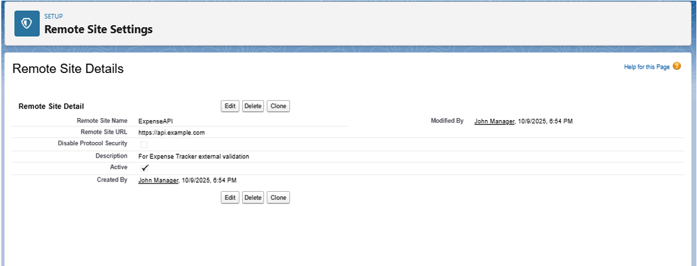

**Step 2: Create Named Credentials**

* **Purpose:** To securely store the API endpoint URL and its authentication credentials (like a password or OAuth token). This is the modern best practice as it separates sensitive data from your Apex code, making it more secure and easier to maintain.
* **Navigation:** Go to **Setup** → **Security** → **Named Credentials** → **New Named Credential**.
* **Configuration:**
  + **Label:** Expense_API_Credentials
  + **URL:** https://api.example.com (This is the base endpoint for the API)
  + **Identity Type:** Select Named Principal if all users share one integration credential.
  + **Authentication Protocol:** Choose the method required by the external API, such as Password Authentication or OAuth 2.0.

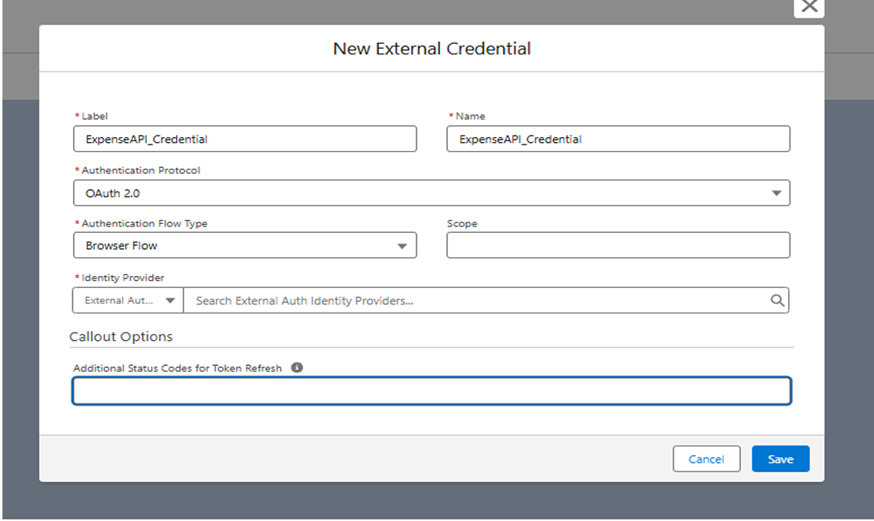

**Step 3: Implement Apex Callout Service**

* **Purpose:** To write the Apex code that makes the actual API request (callout) to the external service. This code will reference the Named Credential created in Step 2 to handle the endpoint and authentication seamlessly.
* **Navigation:** Go to **Setup** → **Apex Classes** → **New**.
* **Example Class:** ExpenseAPIService
  + This class would contain a method (e.g., validateExpense) that uses the HttpRequest and HttpResponse classes to send data to and receive a response from the external API.

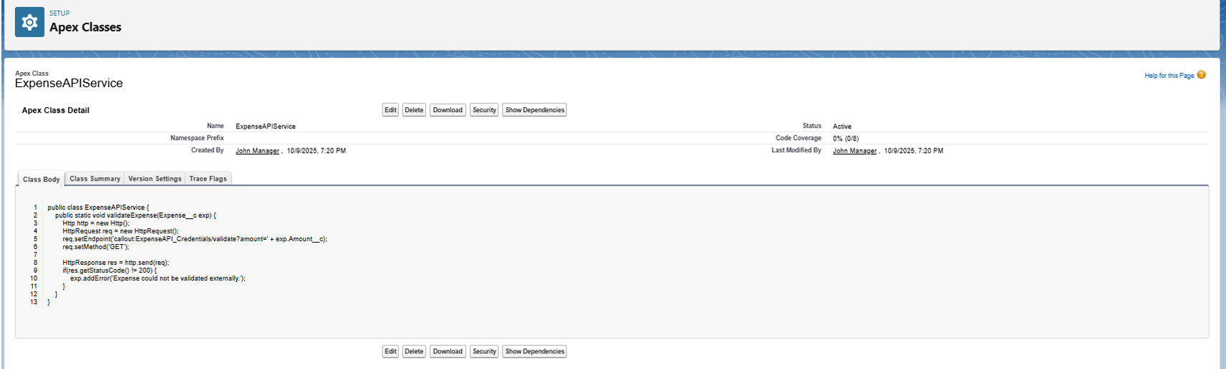

**Step 4: (Optional) Configure Outbound Messaging with Events**

* **Purpose:** To notify external systems *from* Salesforce in real-time when an expense record changes (e.g., "Expense Approved" or "Expense Submitted").
* **Method A: Platform Events**
  + **Navigation:** Go to **Setup** → **Platform Events** → **New Platform Event**.
  + **Use Case:** Define a custom event (e.g., Expense_Approved__e). Your Apex trigger or Flow can then "publish" this event. An external system can "subscribe" to this event channel to receive the notification.
* **Method B: Change Data Capture (CDC)**
  + **Navigation:** Go to **Setup** → **Change Data Capture**.
  + **Use Case:** Enable CDC for the Expense object. Salesforce will automatically publish change events for any creation, update, or deletion of expense records. External systems can subscribe to this data stream.

**Step 5: Review Security & API Limits**

* **Purpose:** To ensure the integration is stable, secure, and operates within Salesforce's governor limits.
* **Key Actions:**
  + **Monitor Limits:** Regularly check API callout usage under **Setup** → **System Overview** → **API Usage**.
  + **Scope Permissions:** Ensure that only the necessary profiles or permission sets have access to the Named Credentials.
  + **Trust Domains:** Only add trusted, secure (HTTPS) domains to your integration settings.

**Phase 7 Complete**

The Expense Tracker application is now capable of secure, two-way communication with external systems. Salesforce is configured to trust external endpoints, store credentials securely, and call external APIs. The system can also proactively notify external services of record changes.